How to create Download Template and upload template

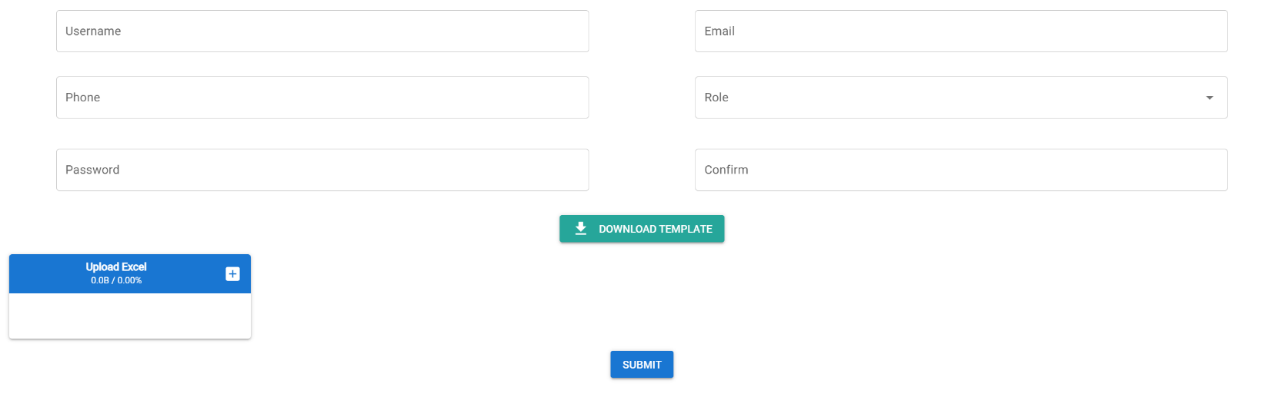

- Install xlsx for excel template:
>> npm install xlsx

- Create sample template in the project folder : public/template.xlsx

- Create button to upload template:

<div class="q-ma-md text-center">
<q-btn
label="Download Template"
color="secondary"
icon="download"
href="/template.xlsx"
target="_blank"
/>
</div>

Explain : href="/template.xlsx" target="_blank" ពេលគេចុច ទៅវានឹងទៅ Download file location នឹងហើយ
ចប់វគ្គ អោយគេ​ download template យកទៅប្រើ
- Update data from the template: update batch data

